# Recommended Thonny Configuration

This is my recommended configuration of the Thonny IDE. I strongly encourage you to configure your installation to match my recommendation.

To access the Thonny configuration area, choose **Tools,** then **Options…**.

Configure the **General** tab, to look like this.

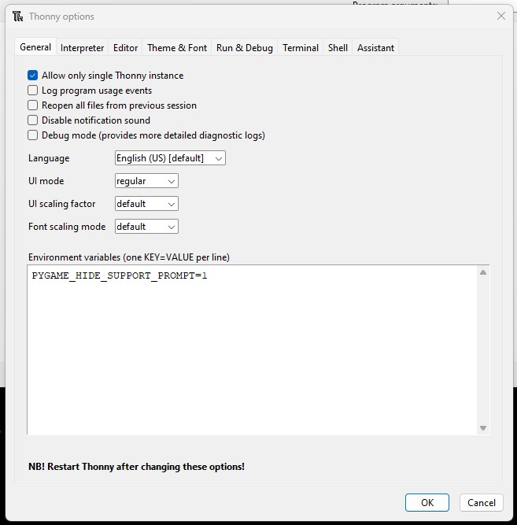

Configure the **Editor** tab, to look like this.

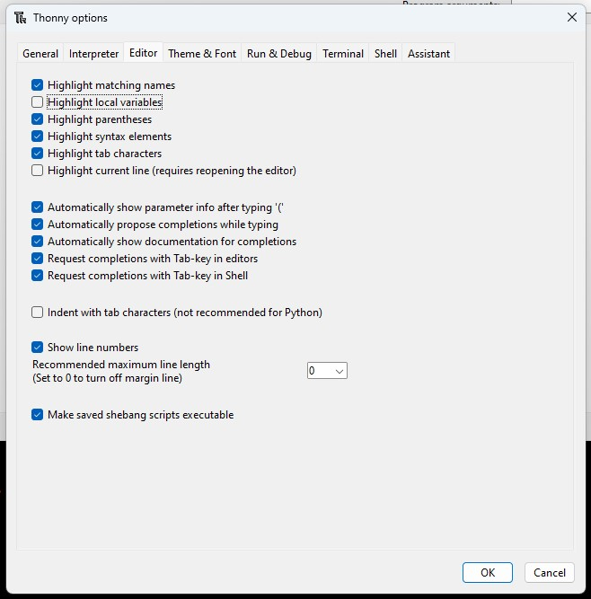

Continued on the next page…

Configure the **Run & Debug** tab, to look like this.

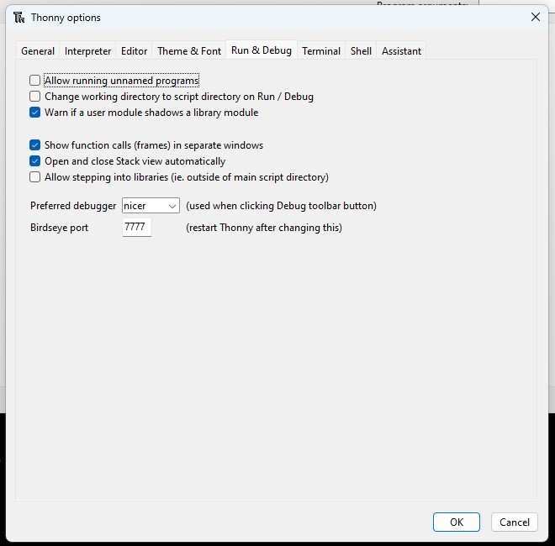

Continued on the next page…

Configure the **Assistant** tab, to look like this.

